Andreas comments on uncertainty calculator 15_5_26
There are 3 parts to this feedback: A flags a potential major calculation error in the tool. B gives specific comments on each page of the tool. C gives general feedback on a pilot test-run of the tool and suggestions for revised report outputs.

- Major issue to flag:
I suspect there are errors in the calculation of direct N2O emissions and indirect N2O emissions. I input Zimbabwe data for intensive dairy system in the custom upload template and ran the same input data using the tool and using @Risk in Excel as well as in the IPCC 2019 software. Results highlight significant differences in the level of direct and indirect N2O emissions from manure management. (I could not check for direct and indirect N2O from pasture deposit because the downloadable reports from the tool do not include these emission sources.) I also checked the @Risk excel file calculations against the same input data in the IPCC software, and the results are identical, so I’m sure the issue is with the tool calculations. In the screenshot below, you can see (1) for total direct N2O emissions, the ‘real’ mean (i.e. as directly calculated by Excel) is not in the 95%CI from the tool’s simulated mean. I’m not sure of the reason, but considering that the same EF3 values were used in all calculations, I suspect it may be the calculation of N excretion in the tool is not correct, or it may be to do with the calculation of weighted mean EF3 which is dependent on how the MMS% values are treated; and (2) for total indirect N2O emissions, the tool’s simulated mean is also much lower than the Excel mean. N excretion is also an input into this calculation, and needs to be checked. In addition, since the % deviation from the mean calculated in Excel and simulated in @Risk is greater than that for direct N2O emissions, there may be some other issue with the calculations. See section C below in which I find that sensitivity analysis identifies some parameters as sensitive that should not appear in those equation chains. Another possible reason may be to do with whether Fracgas and Fracleach (IPCC 2019 Table 10.22) should actually be percentages (e.g. “30”) or fractions (e.g. “0.3”) and how these are treated in the equations. (IPCC 2019 Table 10.22 shows fractions, while the IPCC software requires them to be entered as percentages, but I’m not sure how the tool is implementing these equations.)
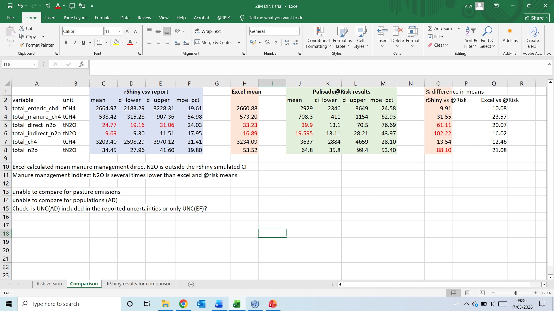

- Specific comments on each page
“Home” page
Comment | How it was addressed
1. Minor edit: “5. Formats results for IPCC inventory reporting (IPCC 2006 Vol. 1 Ch. 3, Table 3.3)”
2. Minor edits: “Emission sources covered: Enteric fermentation CH₄, Manure management CH₄, Manure management N₂O (direct and indirect), and N₂O (direct and indirect) from dung and urine deposited on pasture.” Subscripts need to be added throughout the tool’s pages and reports
3. “Quick start: try the tool immediately, go to 1. Data input”, but on this opening page you have to first select single year or trend. I found it’s quite easy to miss this at the bottom of the opening page. If possible, move it to the 1. Data input page?
4. What does this tool do? “Takes your country-specific input data aligned with the IPCC Tier 2 equations, with uncertainty ranges”

What this tool does NOT do:
“It does not produce Tier 1 estimates and is not designed for uncertainty analysis of country-specific Tier 2 methods — the IPCC Tier 2 equation chain is required.”

“Definitions” page
Comment | How it was addressed
5. I am not clear what the definition of “technical” and “core” parameters is and whether referring to this as “tier” is confusing with IPCC use of the word “tier”
6. Parameter “W”. In equation 10.3 this is “Weight”. In equation 10.6 this is “BW” and elsewhere (e.g. equation 10.17, “BW” is used. (a) suggest to note that this is the same parameter in equations 10.3 and 10.6, and (b) somehow “BW” seems more intuitive than “W”. If updated to “BW” this would need to be consistent throughout the tool and the upload templates.
7. “CP” – crude protein – in equation 10.32 is “CP%”
8. Milk: “Set 0 for non-dairy sub-categories” not correct, should be “Set 0 for sub-categories that do not lactate”.
9. “pct_lactating”: this is not an explicit parameter in IPCC. On page “5. Simulate & results” you have “IPCC software-aligned options”, which includes “Cp pro-rate” defined as “fraction of females that calve in a year”. On the one hand, it is correct that these 2 values may be different (e.g. if lactation >365 days or due to abortion etc). On the other hand, (a) IPCC equation 10.8 for lactation assumes that the value of Milk is already adjusted for the proportion of cows lactating, (b) for equation 10.13 the text under Table 10.7 in the 2019 refinement indicates that the value of Cpregnancy should be weighted by the proportion of females pregnant and the weighted value should be used in the equation. So I am wondering how your equations use these two parameters differently? And whether it is both IPCC-compliant and simpler to have just one parameter (pct_pregnant) and leave it to the user to decide whether this value is equal to the value of pct_lactating?
10. FracGASMS and FracLEACH_H: There should be 4 of these listed: FracGASMS for manure management volatilization (Table 10.22), FracGASM for dung and urine deposit on pasture (Table 11.3), Frac_leachms (Table 10.22) and Frac_leach-(H) (Table 11.3)
11. C: Growth coefficient for Neg “depends on sex”, edit to “depends on sex and physiological status”
12. Ym: Methane conversion factor: “% of gross energy in feed converted to methane (IPCC Table 10.12)”
13. Fat “Milk fat content of the diet” should be “fat content of milk”
14. EF4 and EF5: in the Definition column you give the global default values. Seems more consistent to just give the definition and IPCC Table reference in this column, and keep the default values in later columns, considering also that IPCC 2006 and 2019 default values differ
15. You give EF3_PRP but should also add EF3_S for manure management (Table 10.21)

“Resources” page
Comment | How it was addressed
16. Methodological foundations. Add a link to IPCC 2019 Vol 1 Ch 3 on uncertainties
17. “FAO Livestock Activity Data Guidance (L-ADG)”

18. I would put Monni et al. 2007 in the case studies section
19. Maybe add a sub-section for “learning resources” with links to
FAO e-learning on assessing land sector uncertainty
FAO e-learning on Tier 2 for livestock
UNFCCC webinar notes on uncertainty analysis
20. “Case studies” – should it be titled “case studies” or “examples”; and in addition to the journal publications cited, should we add some online available examples from national inventories? If so, I can compile a few links
21. Eventually we may have at the top a sub-section for resources specific to this tool. I think we’ll need three types of content:
(a) specific to explaining how the tool works (if it’s not transparently documented then it’s not IPCC-compliant)
(b) how to use the tool (e.g. tool-specific guidance such as “if you are not accounting for uncertainty of a parameter, enter parameter value and set uncertainty-pct=0…”
I guidance on preparing the uncertainty inputs before entering them in the data input templates
In terms of timing, I think we should think about (b) and (c) soon so that drafts are available for the beta-testing by partners

“1 Data input” page – see also comments below these tables about general user feedback
Comment | How it was addressed
22. Custom upload templates:
22a: “Parameters” tab includes several parameters for manure management that would be more appropriate in the Manure_management tab because they are specific to manure management systems rather than animal sub-categories, e.g. EF3, EF4, EF5, Fracgas,Fracleach
22b: some parameters are repeated in the “parameters” and “Manure_management” tab, e.g. Bo, and I’m not sure which tab the tool picks the value from. If it’s specific to an animal type (e.g. Bo values vary between dairy and non-dairy) then may be better in the “parameters” tab.
22c: columns L and M are listed as “auto-fill” but did not auto-fill unless I placed the cursor at the end of the formula. If it does not auto-fill, this does not impact on the upload into the tool, but the autofill of lower and upper CIs is useful for the user to have some QC check when filling the templates before upload
22d: In the “manure_management” tab, Bo has a value but no columns to fill uncertainty_pct or lower & upper CIs
22e: “Parameter time series”: I could not work out how to enter my data in the template. There are no columns for cattle type, aggregation level and sub-category. The filled example template looks like an aggregation or example for one production system only, so hard to reproduce from a more complex input dataset.
23: Adjusting Cfi for winter temperature. You have the mean daily temperature in winter as an advanced option in ‘5. Simulate and results”. I think it would make sense to include it in the basic upload template and all processes thereafter; if a country is not using this adjustment, then it can be left blank and the app should give a default auto-fill value that negates the winter-specific adjustment of Equation 10.2, but including this option from the start would help make the tool IPCC-compliant. Also, some countries may apply this adjustment to some production systems (e.g. ‘high Andes’) but not others (e.g. lowland) in the same country.

“2 QAQC” page
Comment | How it was addressed
24. General feedback: the tests were useful and picked up errors and omissions and gave useful advice on more appropriate PDFs.
25. Implementation of the benchmark deviation tests works – it raises lots of flags, but it often looks like the benchmarks used are not appropriate, possibly because IPCC sub-categories are defined differently from country-specific ones, or because the default values for the benchmark is from a different IPCC version (2006 or 2019) etc, e.g. benchmark references to Monni et al (2007) seem inappropriate unless they are also reflected in the IPCC guidelines. Overall, this test is useful, but perhaps just check how it applies default benchmark values to country-specific categories

“3 Uncertainty” page
Comment | How it was addressed
26. The current set-up is to edit the flagged or failed items in the ‘3. Uncertainty’ page. As a user, I found it logical to go back to the template, edit in the template and re-upload so that my final template contained a record of my final values. I also did this because there are more than 100 parameter values for just 1 production system in my pilot test-run, and it was easier to find and edit them in the template than using the search bar and editing in the tool. Maybe the current set-up is fine and the user guide can note both options for editing flagged/failed values…

“4 correlations” page – I have no comments here, as I did not use the correlations option due to comment 22e above
Comment | How it was addressed

“5 Simulate and results” page
Comment | How it was addressed
27. Emission sources to include: I suggest to list pasture deposition direct N2O and indirect N2O separately because they are separate IPCC reporting categories
28. IPCC software aligned options: see comments 9 and 23 above
29. Possible bug? I checked the “Run uncertainty decomposition (AD/EF/Combined)” option, but there was no decomposition shown in my results. (I note it does work when running a simulation for the default in-app datasets, but didn’t work for my uploaded custom dataset)
30. “Use 10,000 iterations for reliable results” – is there a basis for this statement? I seem to recall when I tested this with @Risk some years ago, 10,000 still led to quite large variation that was further reduced by more iterations. NB, in my test-run with Zimbabwe data, I ran the simulation twice with 25,000 iterations and got fairly consistent results
31. Minor edit: “What to do: Configure simulation settings on the left, then click ‘Run Monte Carlo Simulation’ at the bottom of the left-hand panel”
32. After running a simulation, the results are displayed at an inappropriate level of aggregation: results are given for each animal sub-category, whereas IPCC would require aggregation at the level of “dairy cattle” and “other cattle” for each emission source. Users may be interested in other levels of aggregation (e.g. comparing uncertainty for different production systems entered in the custom template “Parameters” tab column B) and potentially at the sub-category level (column C). Would it be possible before running the simulation to have the IPCC dairy vs other cattle as a default with the option for users to select additional lower levels of aggregation for results reporting?
33. First time, the simulations worked. Today I re-tried with the same uploaded template and got the error “--- Starting simulation ---
Iterations: 5000
GWP: AR5
EF correlation: none (independent)
ERROR: replacement has 0 rows, data has 5000
Custom data uploaded: 120 parameters loaded from uncertainty_template_ipcc2019.xlsx (country: Zimbabwe)”
I could not determine the cause of the error, but hopefully the eventual user guide can document a number of error types and their solutions
34. Comment applicable to the initial display of results and all other reports subsequent: units (e.g. t CH₄) are not always reported. Please make sure every column in the in-app result displays and the downloadable reports have units displayed.

“6 Sensitivity” page
Comment | How it was addressed
35. The tornado charts list parameters with the parameter abbreviations; to be really useful, it would present the results at the sub-category level of aggregation, e.g. cattle type_aggregation level_sub-category_parameter so that the user can for example identify that the most sensitive parameter is Ym for cows in the semi-intensive system, as opposed to Ym for any sub-category. Is it possible to revise either so that this is a default level of aggregation or to give the user the option to select the level of aggregation for the tornado charts?

“7 IPCC reports” page and related downloaded report results
Comment | How it was addressed
36. The in-app reports show direct and indirect N2O from pasture deposit separately, which is good. The csv download and word reports do not. I suggest to always disaggregate these results if selected by the user
37. The word report section 4 only reports by gas, not by emission category
38. Excel download did not work
39. See Section C below for suggested revised template for word download

- Overall feedback on a pilot test-run and suggestions on reporting
I input the values from Zimbabwe intensive dairy system (5 animal sub-categories) into the 2019 template and ran the simulation with the following settings:
- Single year
- No correlations
- 25000 iterations
- Random seed 42
- AR5, all emission sources selected
(I also ran it in @Risk with the same inventory values, and to the extent possible the same PDFs and uncertainty_pct inputs. Results for manure management will differ because I was not able to apply the Dirichlet constraint to MMS% values.)
My general experience was that using the tool was quite smooth and feasible to enter all the data required for 5 sub-categories. QAQC checks were useful (some of the benchmarks warnings seemed inappropriate but it was OK to ignore them and proceed). I did editing of ‘fails’ in the template and re-uploaded. The reason I did this was (a) with 120+ parameters in the uploaded data, the line by line in-app readouts were hard to see in one page, whereas with the Excel template it was much easier to find the parameters I was looking for. If I had 500+ parameters (e.g. 4 production systems with 5 sub-categories per system), I imagine the in-app editing would be even more challenging. Also, (b) if I edited in the excel sheet, I could store my final input values in the template in case I wanted to re-run it later.
Selecting options for the correlations and simulation was quite easy. Finding the options could benefit from clearer guidance at the top of each page, or an accompanying user manual.
Presentation of results was initially confusing for several reasons:
- The ‘headline’ results in the coloured bubbles refer to total CH4 and total N2O, whereas an inventory user is always interested in IPCC-defined emission sources, e.g. enteric fermentation, manure management CH4 etc. The headline margin of error I guess refers to total CO2 equivalents, but again, this is not an IPCC-relevant number.
- The ‘system breakdown’ is per animal sub-category, whereas users initially require a breakdown by dairy/other cattle, and may be interested in second-level categories as defined in column B of the template for uploading. Results at cattle sub-category level would only be for the more advanced user.
Sensitivity analysis tab overall is good. The dropdown to select the emission source is useful, but may need to highlight to the user that this is a dropdown for selection.
In terms of tornado chart results (comparing SRC with the @Risk ‘contribution to variance’ tornado chart):
- Enteric: the top 5 are identical and in the same order. There’s some variation for the others because @risk gives the result per system_sub-category_parameter, which is more specific than what the tool presents
- MM CH4: top parameters are quite different (see charts). MCF values are among the most important in @Risk, but are not in the top 10 in the tool. Not sure why? (uncertainty_pct should be very similar in the 2 tools, but the tool used the Direchlet constraint for MMS% while the @Risk did not)
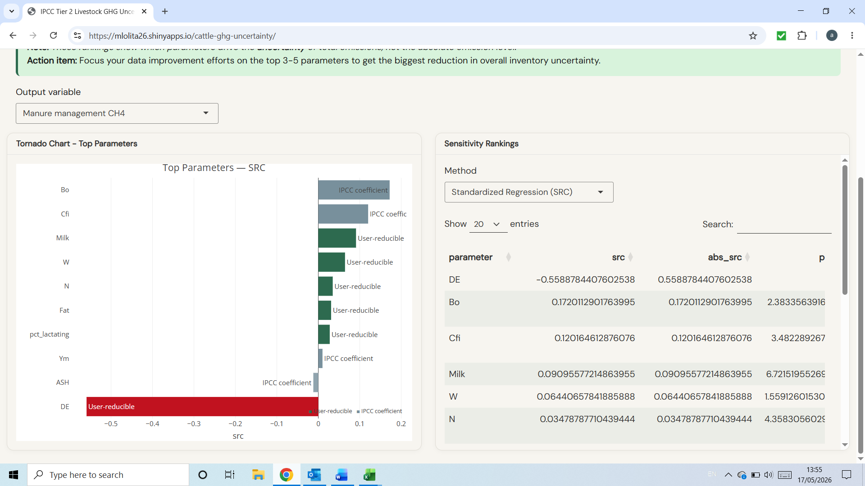 | 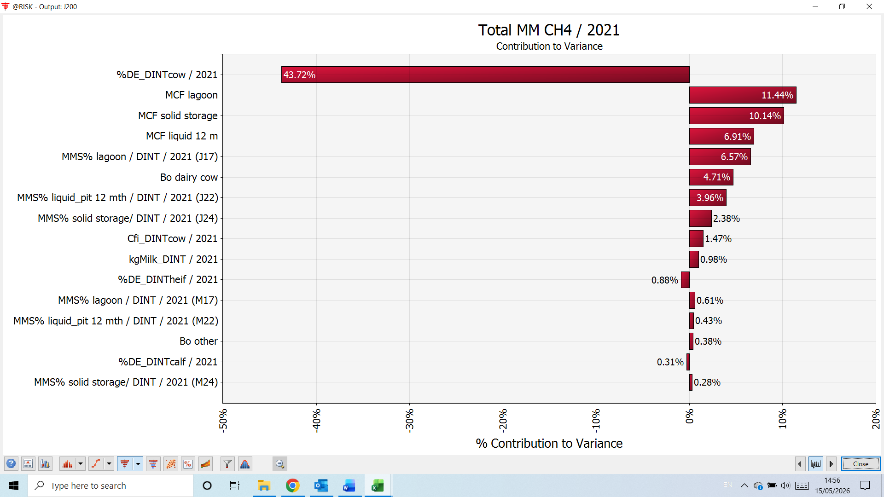

- MM Direct N2O: similar to CH4, EF3 is influential in @Risk but not in the tool
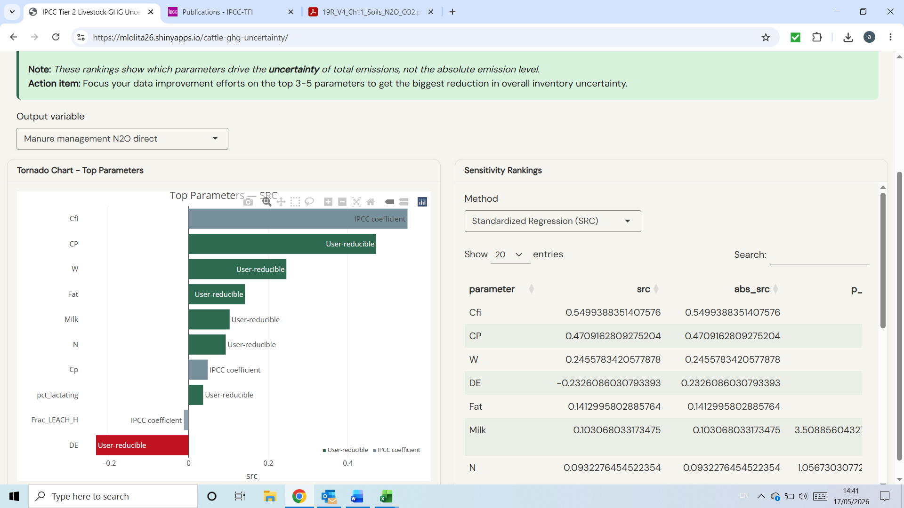 | 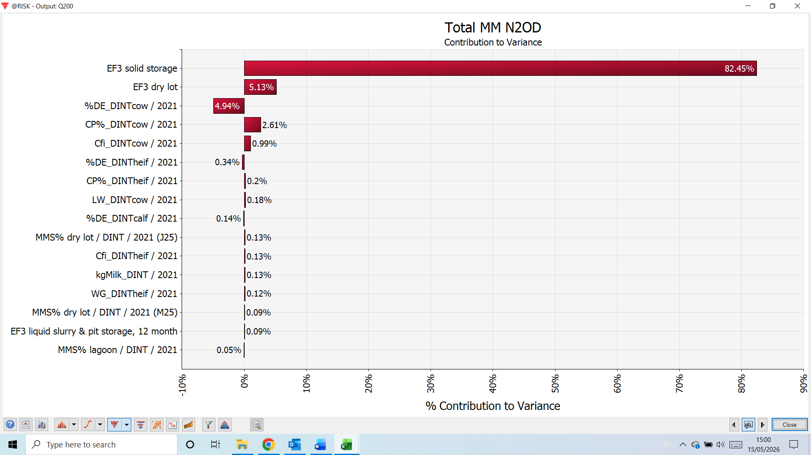
ISSUE TO HIGHLIGHT: FRAC_LEACH_H is not a variable in the Direct N2O calculations
- MM indirect N2O: Fracleach and Fracgas do not appear in the top variables in the tool, which is surprising given their large uncertainty ranges
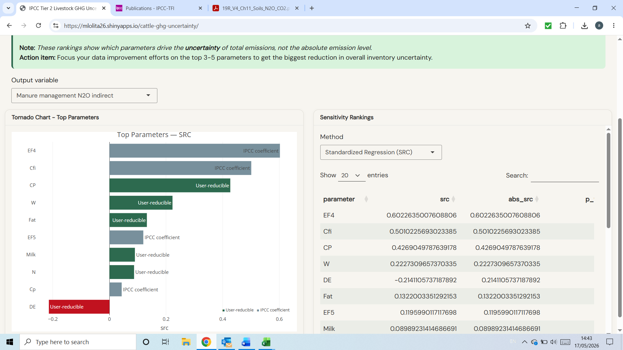 | 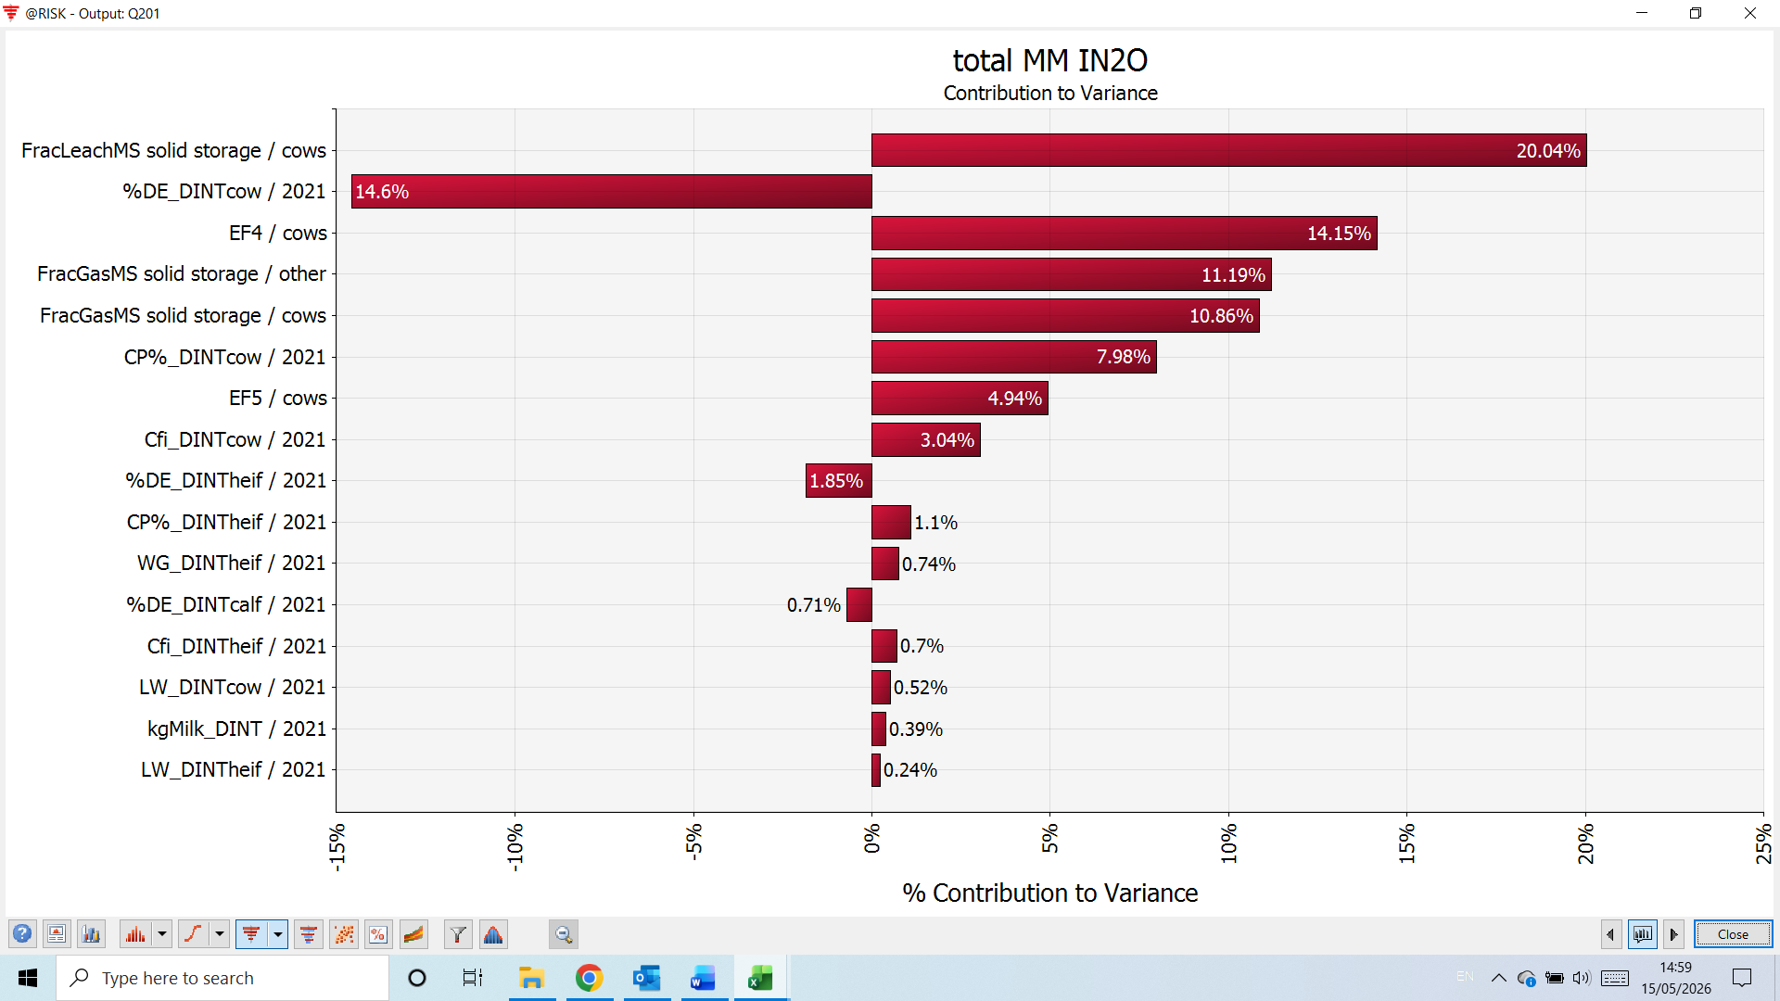

- Direct N2O pasture
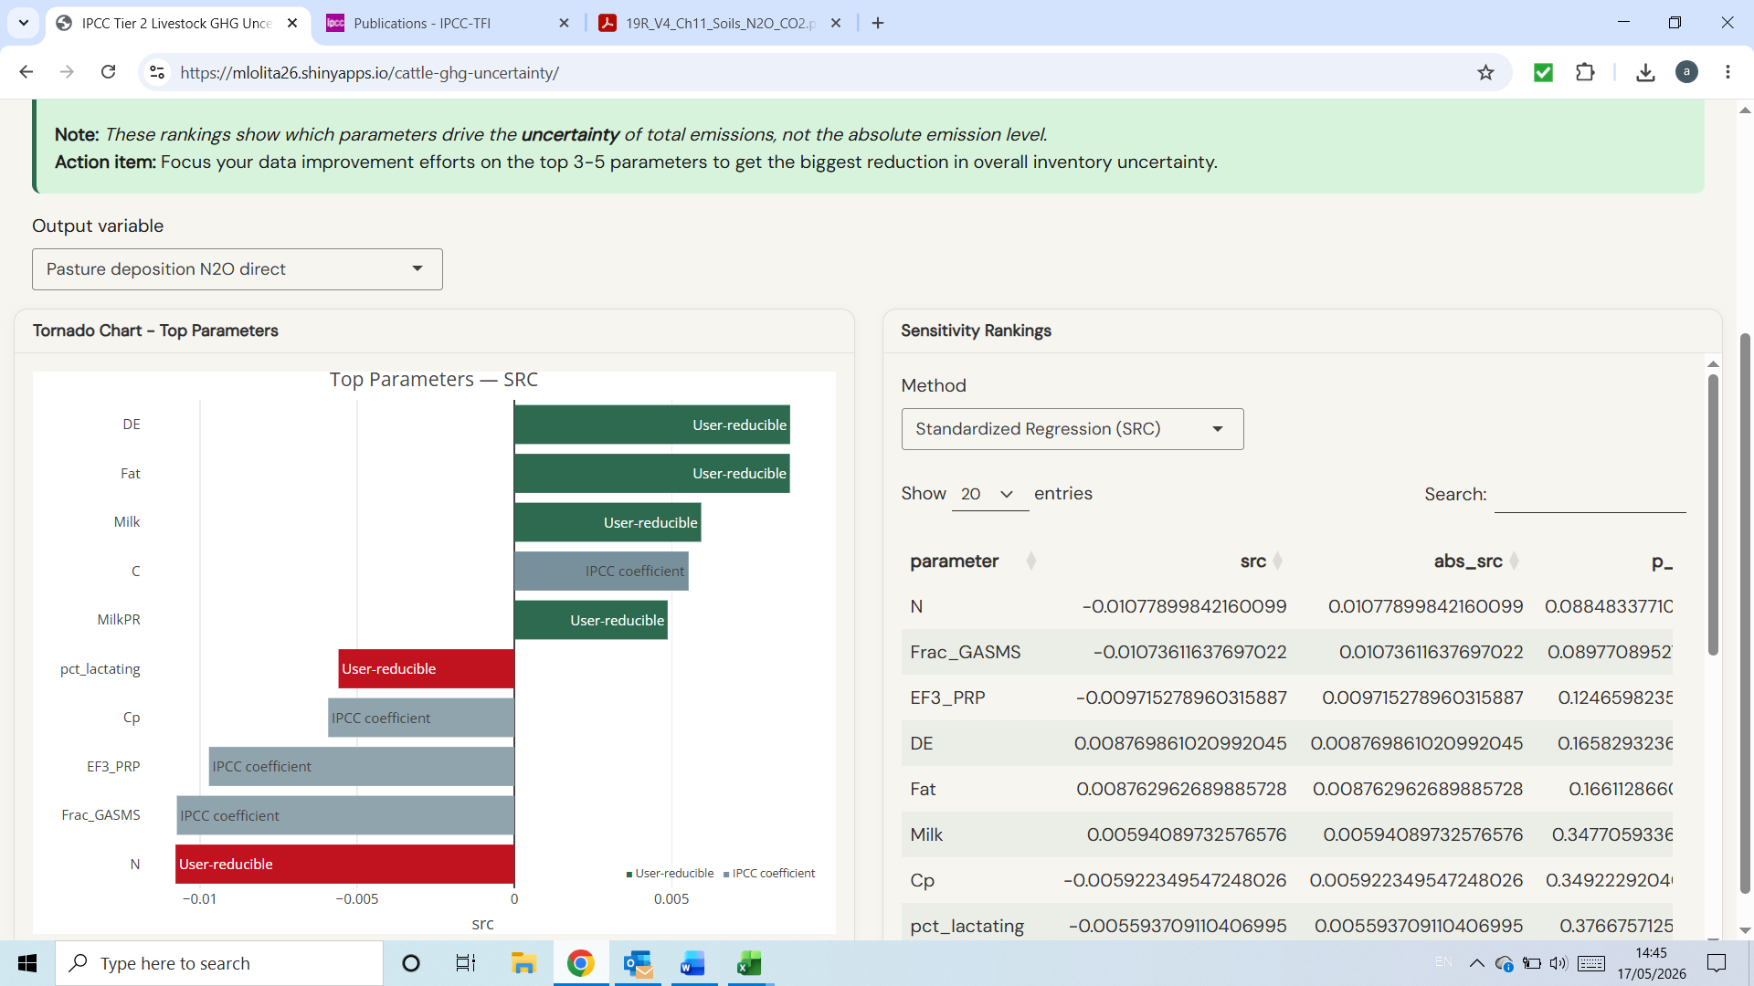 | 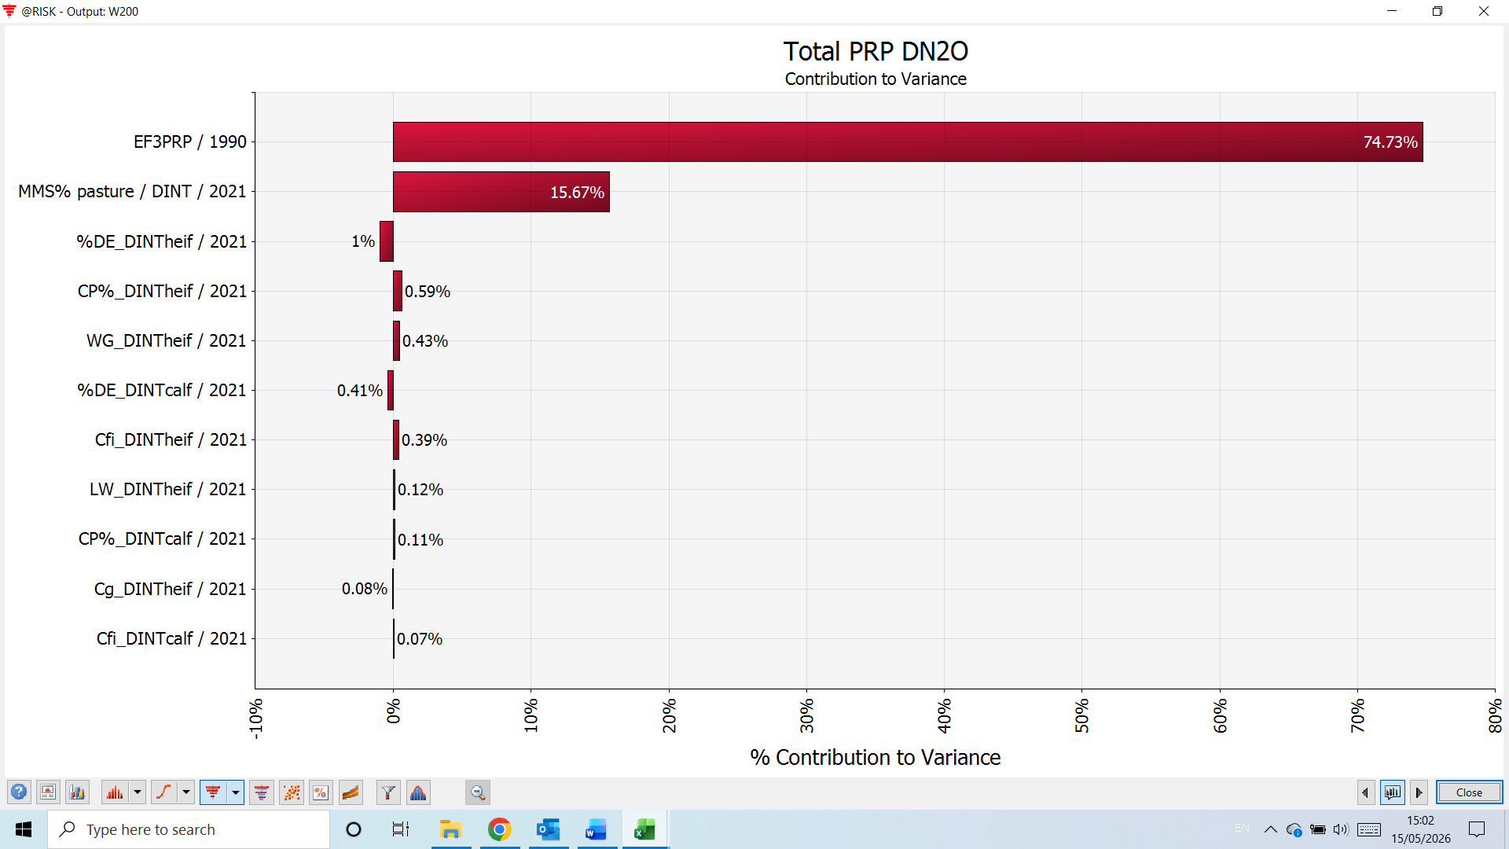
ISSUE TO HIGHLIGHT: Fracgasms is not a parameter in the direct N2O from pasture equations
- Indirect PRP N2O:
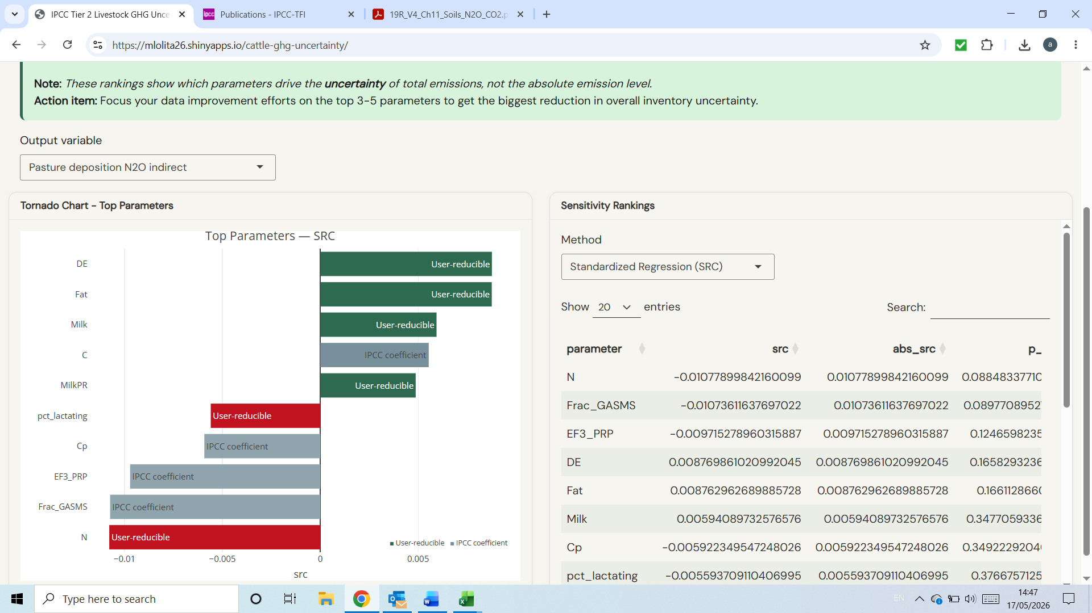 | 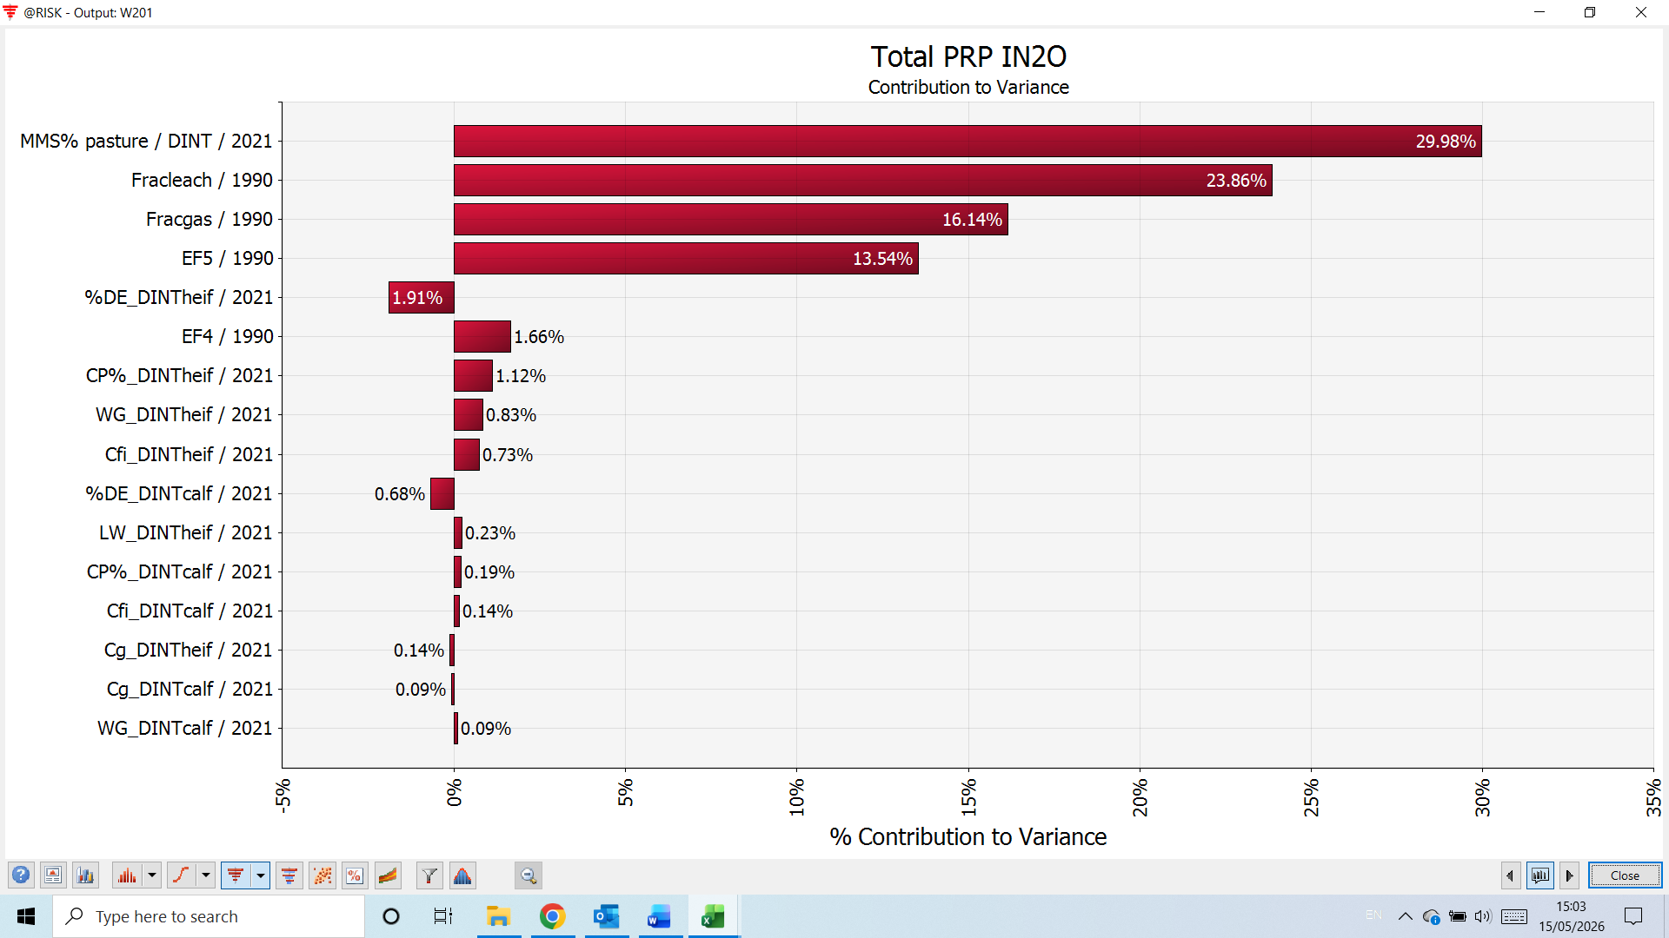

ISSUE TO HIGHLIGHT: FRAC_LEACH_H is not a variable in the Direct N2O calculations
The result downloads need to be further developed:
- The excel download doesn’t work: in my download tab in Chrome it tells me “site wasn’t available”
- The csv file could benefit from
  - Put the name of the emission category in column A instead of at the end of the table
  - Pasture direct and indirect N2O were not reported separately, and probably were not included in ‘total N2O’
  - In future versions, consider the level of aggregation as point out above, i.e. dairy/vs other as default, possible user-defined production systems as a further level…
- The word file needs to be further developed. In the page below, I’ve proposed changes in content.

Cattle GHG Tier 2 Uncertainty — Single-year run
Generated 2026-05-17 13:53 UTC. Approach 2 Monte Carlo simulation per IPCC Vol 1 Ch 3.
Executive summary
Total emissions: 98,823 t CO2eq with a 95% confidence interval of [81,301, 120,866]. Coefficient of variation: 10.3%; 95% margin of error: 20.0%. The single dominant uncertainty driver is DE (SRC = -0.64). These figures are based on 25,000 Monte Carlo iterations under the IPCC Approach 2 method.
For IPCC reporting, the key results are:
Activity data uncertainty:
Reporting category | Simulated mean | Lower CI | Upper CI | MoE_pct
population

Emission factor uncertainty:
Reporting category | Simulated mean | Lower CI | Upper CI | MoE_pct
Enteric
Manure CH4
Manure direct N2O
Manure indirect N2O
pasture direct N2O
pasture indirect N2O

1. What was run
Setting | Value
Iterations | 25,000
AD correlations | none
EF correlations | none
Comparison run (no corr.) | No
GWP basis | AR5
Seed | 42
Analysis mode | single
Emission sources | enteric_ch4, manure_ch4, manure_n2o_direct, manure_n2o_indirect, pasture_n2o
4. Headline results — by source
Mean total emissions per source with the 95% confidence interval, coefficient of variation (CV%) and 95% margin of error (MoE%) from the Monte Carlo run.
Source | Mean | CI lower | CI upper | CV % | MoE %
Total CO2eq | 9.882e+04 | 8.13e+04 | 1.209e+05 | 10.3 | 20
Total CH4 | 3203 | 2595 | 3975 | 11 | 21.5
Total N2O | 34.46 | 27.96 | 41.63 | 10.2 | 19.8

5. Sensitivity ranking — top 10 drivers
Standardised regression coefficient (SRC) and partial rank correlation (PRCC) of each input parameter against total CO2eq. Larger absolute values dominate the output uncertainty.
Parameter | SRC | PRCC
DE | -0.642 | -0.830
Ym | 0.529 | 0.792
Cfi | 0.317 | 0.620
Milk | 0.204 | 0.439
W | 0.140 | 0.326
Fat | 0.089 | 0.201
N | 0.078 | 0.192
Bo | 0.078 | 0.181
pct_lactating | 0.073 | 0.172
CP | 0.029 | 0.066
6. Charts
Total CO2eq — Monte Carlo distribution
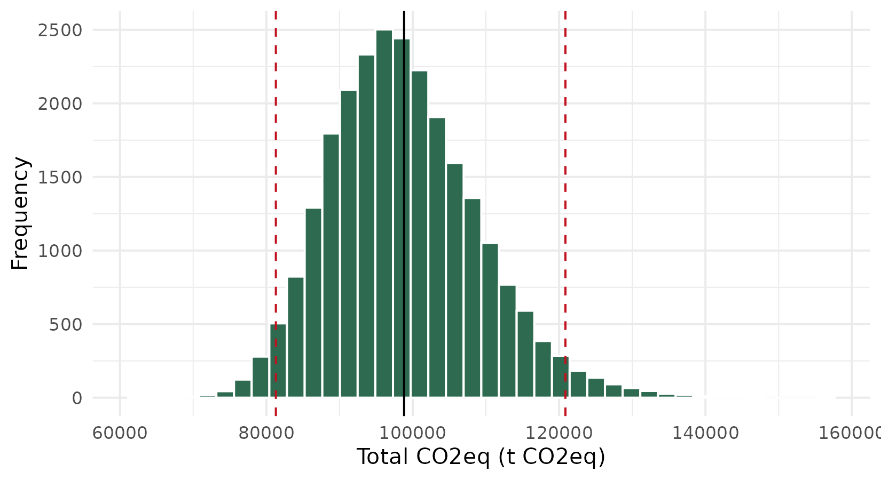
Sensitivity tornado
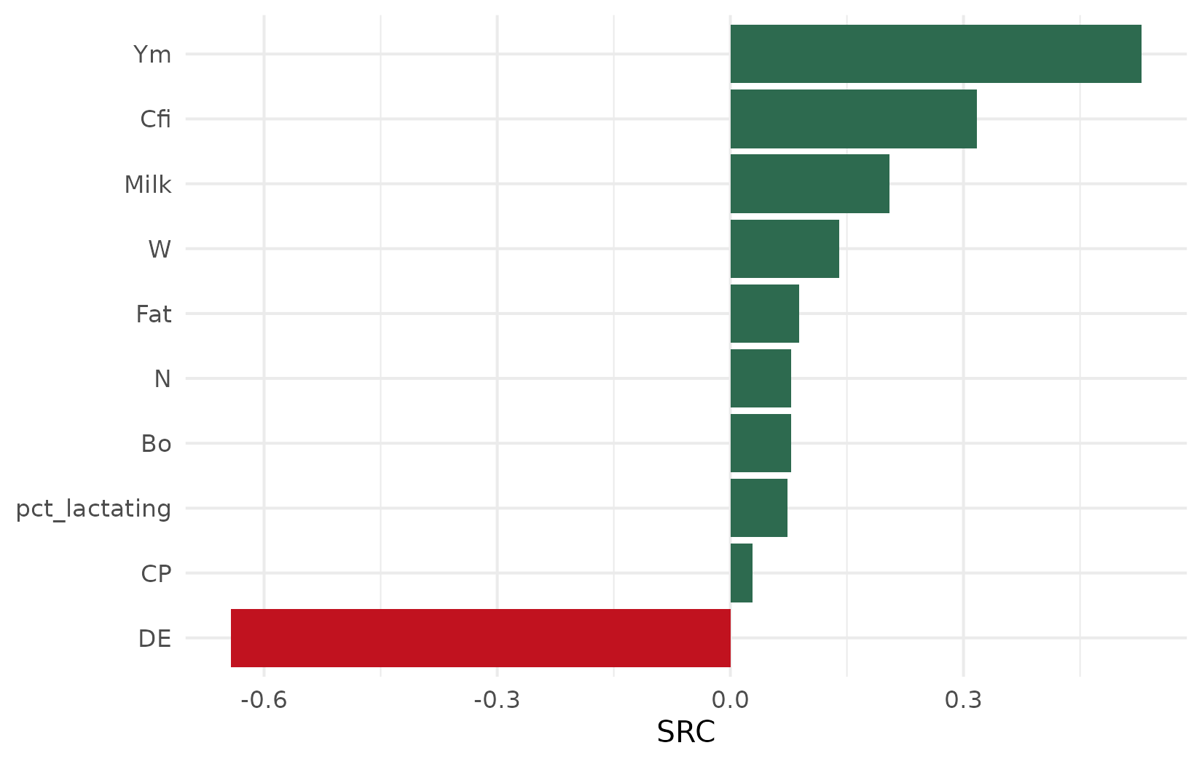
Per-source emission distributions
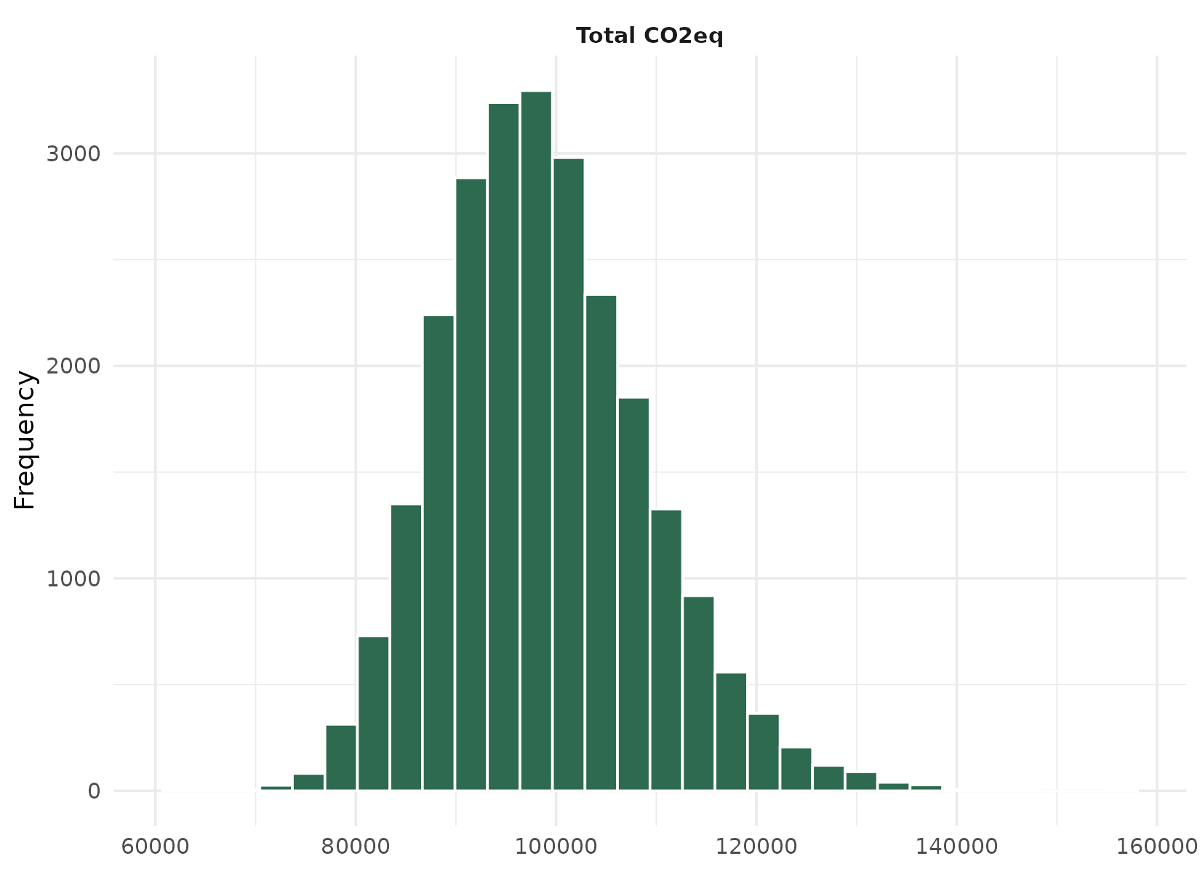
7. IPCC reporting context
This run follows IPCC 2006 Vol 1 Ch 3 Approach 2 (Monte Carlo) for combined uncertainty estimation. The headline CV% in section 4 is the value to enter in column J of the national inventory uncertainty table (Annex 7 / IPCC Table 3.3). The activity-data vs emission-factor split in section 3 follows the convention adopted in this tool — AD = animal population (N) only; coefficient (EF) = the 23 IPCC equation parameters that combine into the per-head emission factor.
Where parameters were auto-filled (section 2), the IPCC default carries the uncertainty bounds suggested by Penman et al. (2000) and Monni et al. (2007). For parameters with country-specific values, the uncertainty bounds entered on the Uncertainty tab of the app drive the Monte Carlo distribution.

Generated by Cattle GHG Uncertainty Calculator on 2026-05-17. CGIAR Alliance / Bioversity-CIAT — funded by the Global Methane Hub.

